Class Time:
Names:

Hypothesis Testing of Two Means and Two Proportions: Lab I

Student Learning Outcomes:
- The student will select the appropriate distributions to use in each case.
- The student will conduct hypothesis tests and interpret the results.
Supplies:

- The business section from two consecutive days’ newspapers
- 3 small packages of M&Ms®
- 5 small packages of Reese’s Pieces®
Increasing Stocks Survey
Look at yesterday’s newspaper business section. Conduct a hypothesis test to determine if the proportion of New York Stock Exchange (NYSE) stocks that increased is greater than the proportion of NASDAQ stocks that increased. As randomly as possible, choose 40 NYSE stocks and 32 NASDAQ stocks and complete the following statements.

- Ho: ____________
- Ha: ____________
- In words, define the random variable

- The distribution to use for the test is __________________

- Calculate the test statistic using your data. ________________

- Draw a graph and label it appropriately. Shade the actual level of significance.
  - Graph: 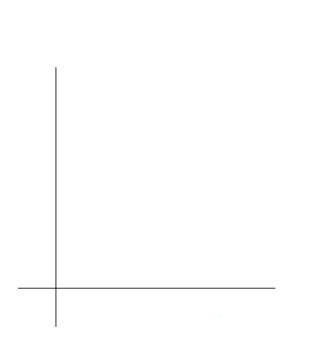
  - Calculate the p-value

- Do you reject or not reject the null hypothesis?

- Write a clear conclusion using a complete sentence.

Decreasing Stocks Survey
Randomly pick 8 stocks from the newspaper. Using two consecutive days’ business sections, test whether the stocks went down, on average, for the second day.

- Ho: ____________
- Ha: ____________
- In words, define the random variable.

- The distribution to use for the test is

- Calculate the test statistic using your data.

- Draw a graph and label it appropriately. Shade the actual level of significance.
  - Graph:
  - Calculate the p-value

- Do you reject or not reject the null hypothesis?

- Write a clear conclusion using a complete sentence.

Candy Survey
Buy three small packages of M&Ms and 5 small packages of Reese’s Pieces (same net weight as the M&Ms). Test whether or not the average number of candy pieces per package is the same for the two brands.

- Ho: ____________
- Ha: ____________

- In words, define the random variable.

- The distribution to use for the test is

- Calculate the test statistic using your data.

- Draw a graph and label it appropriately. Shade the actual level of significance.
  - Graph:
  - Calculate the p-value.

- Do you reject or not reject the null hypothesis?

- Write a clear conclusion using a complete sentence.

Shoe Survey
Test whether women have, on average, more pairs of shoes than men. Include all forms of sneakers, shoes, sandals, and boots. Use your class as the sample.

- Ho: ____________
- Ha: ____________
- In words, define the random variable

- The distribution to use for the test is

- Calculate the test statistic using your data.

- Draw a graph and label it appropriately. Shade the actual level of significance.
  - Graph:
  - Calculate the p-value

- Do you reject or not reject the null hypothesis?

- Write a clear conclusion using a complete sentence.

